**Inventory Management System – Final Iteration**

**Team Exhaustlessness**

**Website URL:** <http://exhaustlessness-final.s3-website-us-east-1.amazonaws.com/>

1. **Authentication**
2. **User signup:**

Our application allows the user to sign-up a new account. However, new users need to be confirmed by the Cognito UserPool admin upon signing up, which is Minh Hang. Therefore, for simplicity, we provided you with the following user credentials to test functionalities of our applications. If you need more user accounts for testing purposes, please email [mgradetsky@wpi.edu](mailto:mgradetsky@wpi.edu)

**Manager users:**

|  |  |  |  |
| --- | --- | --- | --- |
| **StoreID that user is assigned to** | **email** | **userID** | **password** |
| 596c21e0-6df4-11ed-85f2-b3a6f63399b3 | [manager1@test.com](mailto:manager3@test.com) | eba35b66-77cf-4831-9c85-c03eace8ad20 | Password1! |
| None but can be assigned via the “Corporate - Create Store” use case | [manager2@test.com](mailto:manager5@test.com) | e5d501ae-6e21-4a4a-8635-bc5456611a77 | Password1! |
| None but can be assigned via the “Corporate - Create Store” use case | [manager3@test.com](mailto:manager4@test.com) | 08e85709-e3c9-4a7b-a53e-a6c8fc53e26e | Password1! |
| fb722840-74a2-11ed-a5af-51101f5cd299 | [manager4@test.com](mailto:manager2@test.com) | 58a699c0-777a-475e-9fa1-9a0828ff1d4a | Password1! |
| None but can be assigned via the “Corporate - Create Store” use case | [manager5@test.com](mailto:manager1@test.com) | 484d74bc-3d6e-4f54-84a9-bcd669495079 | Password1! |

**Corporate users:**

|  |  |
| --- | --- |
| **email** | **password** |
| Corp1@test.com | Password1! |
| Corp2@test.com | Password1! |
| Corp3@test.com | Password1! |

1. **User login**

Use the “burger” menu button on the top to switch user role. If you select “Corporate”, you will be logged out of previous session and directed to the corporate login page. Similarly, if you select “Manager”, you will be logged out of previous session and directed to the manager login page. Since customers do not need to be authenticated, selecting “Customer” will direct you to the “Customer Homepage”. The “Customer Homepage” will also be the default page when you first load the app.

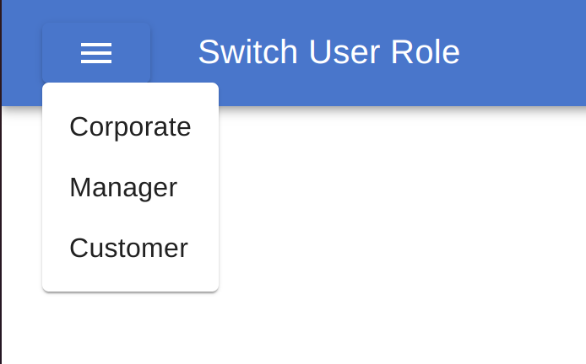

Enter the **user email** and **password** we provided above (**note**: All passwords are set as “Password1!” to enable ease of use for you).

**Note:** There may be some success/failure alerts appearing on the top of the app. The success alerts will dismiss themselves after 2-3 seconds, but you will need to manually close the “failure alerts” if they appear.

If you log in successfully as any **corporate** user, you will be directed to **Corporate Homepage**. All **corporate** users will be able to access the same resources.

If you log in successfully as a **manager** user, there may be two possible scenarios depending on whether you have been assigned to a store by the corporate:

* **Scenario 1:** If you have been assigned to manage a store by corporate, you will be directed to the “Manager Homepage” with the storeID that you manage. For example:

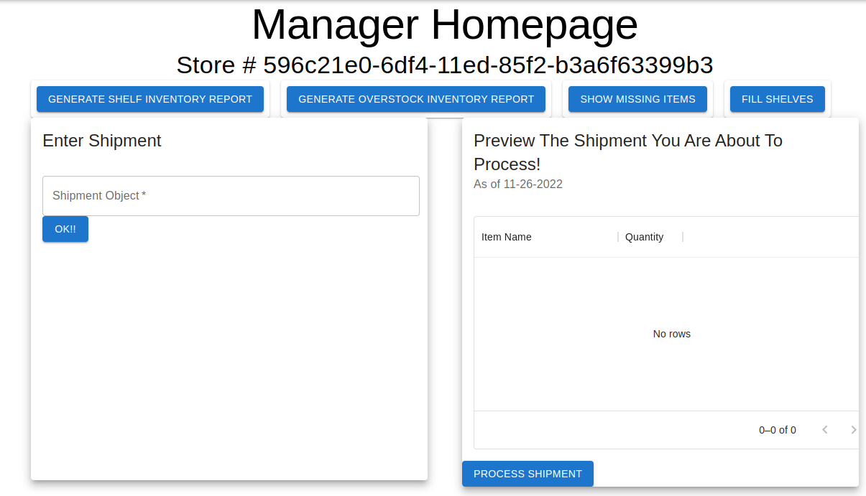

* **Scenario 2:** If you haven’t been assigned to manage a store, you will be directed to a page that looks like follows. Once you have “create store” and assign this manager, next time you log in, you will see scenario 1 being displayed.

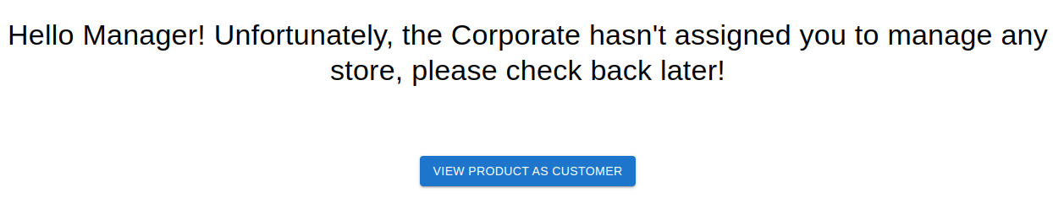

1. **User logout**

You can log out by switching user roles using the burger menu button on the top right or the “Logout” button on the top left (if “logout” is available).

1. **Use Cases for Final Iteration**
2. **Corporate – Generate Total Inventory Report**

When in the corporate dashboard, click on the “Generate Total Inventory Report” and you will see three grids. The first grid is labeled “Stores”, see below. This grid shows all the stores, their respective numbers of items in the store and their inventory valuation.

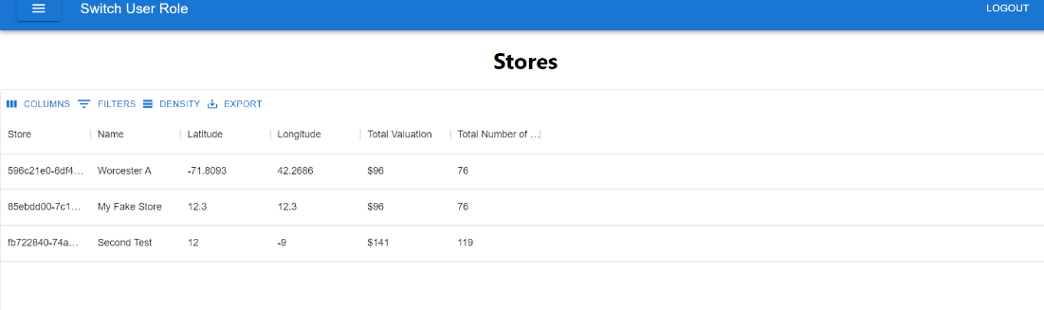

The next grid labeled “Store Items”, see below, shows the items within certain stores with their respective quantities, pricing, and valuation of stock.

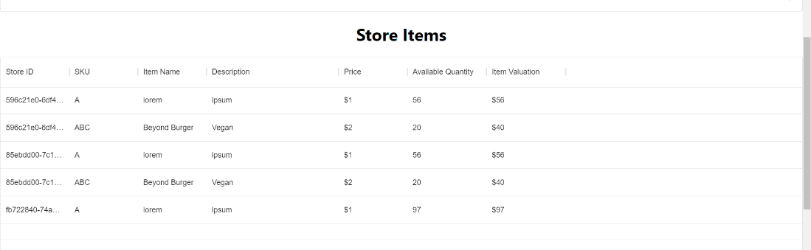

The last grid, labeled “Total Store Valuation”, see below, shows the total number of stores, total valuation of inventory and total number of items.

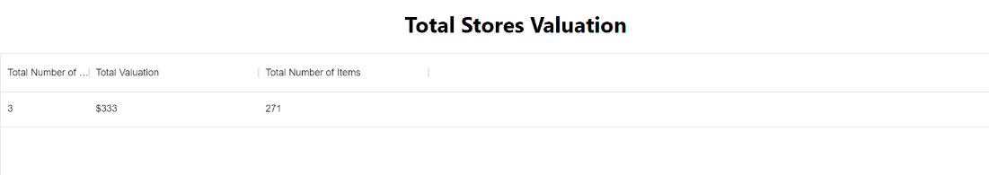

1. **Most Expensive Item**

When in the corporate dashboard, click on the “Most Expensive Item” button. This will provide the corporate user with the most expensive item in the system.

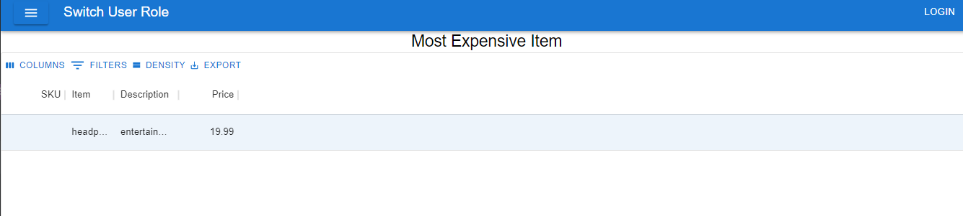

1. **Manager – Fill Shelves**

**Prerequisite:** logged in/authenticated as a manager user and in the “Manager Homepage” page.

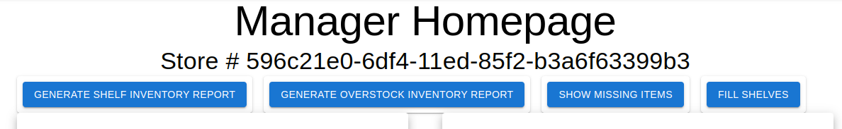

Click on the “Fill shelves” button to trigger the fill shelves use case. This will take the items from the overstock area to fill the store-front shelves.

An alert will appear indicating “success” or “failure”. However, to validate the outcome of the operation, please trigger the “generate shelf inventory” report and “generate overstock inventory report”.

1. **Manager – Show Missing Items**

When in the manager dashboard, click on the “Show Missing Items” button. This will lead you to a screen that shows the items that are missing. These are items that are in the corporate register of items, but are not in the store. To view the whole list, please make use of the arrows circled in red on the bottom right of the page.

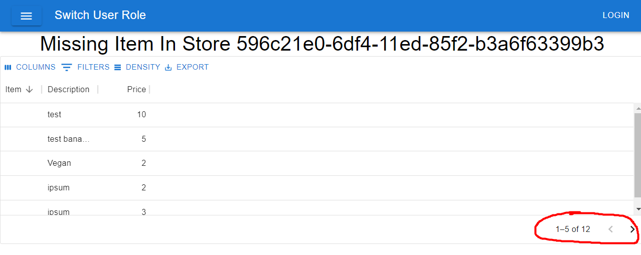

1. **Customer – Buy Items**

Navigate to a store’s page like you would do for the “Customer – Find items on Aisle/Shelf in Store” use case. You will be brought to a page representing a store inventory and looking like below:

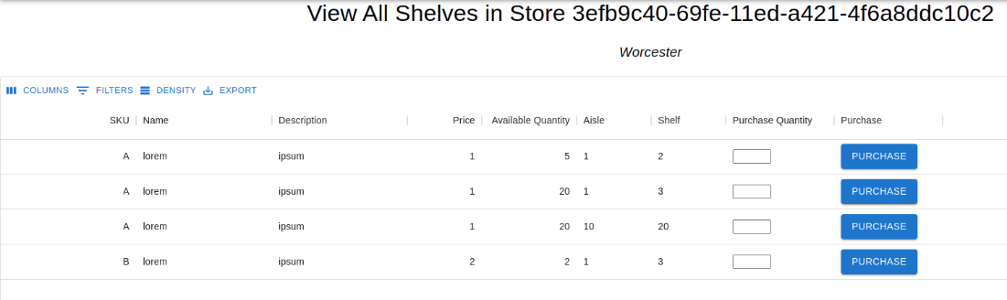

View each item and type in the quantity in the corresponding cell in the “Purchase Quantity” column and click on the blue “Purchase” button on the right.

If the “purchase” action is successful, you will be able to see the “Available Quantity” updated.

1. **Use Cases Delivered in the Previous Iterations**
2. **Corporate – Create Store**

**Prerequisite:** logged in/authenticated as a corporate user and in the “Corporate Homepage” page. Click on “Create Store” button in the horizonal button group. The process of creating a store remains the same as from the previous iteration.

1. **Manager – Process Shipment.**

**Prerequisite:** logged in/authenticated as a manager user who has been assigned to a store and navigate to the “Manager Homepage” page. The home page looks like this

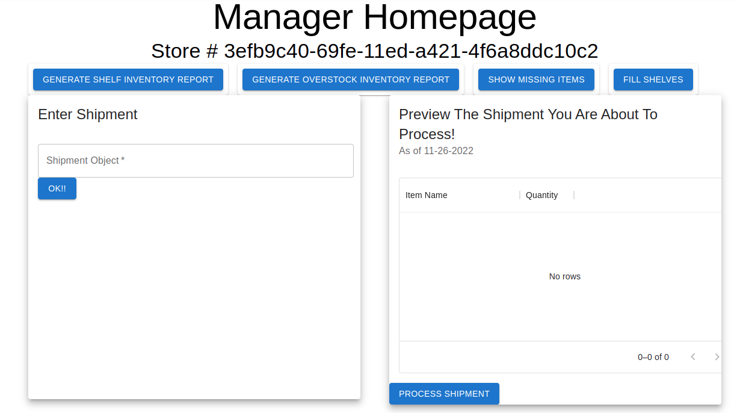

Enter shipment information in the following format in the “Shipment Object *” text field.

Note: if you use a different format, our app might not be able to parse the data!

|  |
| --- |
| {  "shipment": [  { "item" : "sku-1" , "quantity" : "41" },  { "item" : "sku-2" , "quantity" : "2" }  ]  } |

Clicking on the “OK!” button, it will display the shipment information in the “Preview” window on the right. And by clicking on “Process Shipment” it will trigger the process shipment use case.

**Note:** The process shipment will display an alert if the processing is successful or a failure. Sometimes, failure could be because an item hasn’t been assigned a location by corporate, and we are just following “defensive programming” in processing shipments.

1. **Manager – Generate Inventory Report**

**Prerequisite:** logged in/authenticated as a manager user who has been assigned to a store and navigate to the “Manager Homepage” page. Click on “Generate Shelf Inventory Report” button in the horizonal button group.

1. **Corporate Create Item**

**Prerequisite:** logged in/authenticated as a corporate user and in the “Corporate Homepage” page. Click on the “Create Item” button in the horizonal button group. The process of creating an item remains the same as from the previous iteration.

1. **Corporate Assign Item Location**

**Prerequisite:** logged in/authenticated as a corporate user and in the “Corporate Homepage” page. Click on “Assign Item Location” button in the horizonal button group. The process of assigning an item to a location remains the same as from the previous iteration.

Upon successful login/authentication (see section I), you as a corporate user will be directed to “Corporate Homepage”.

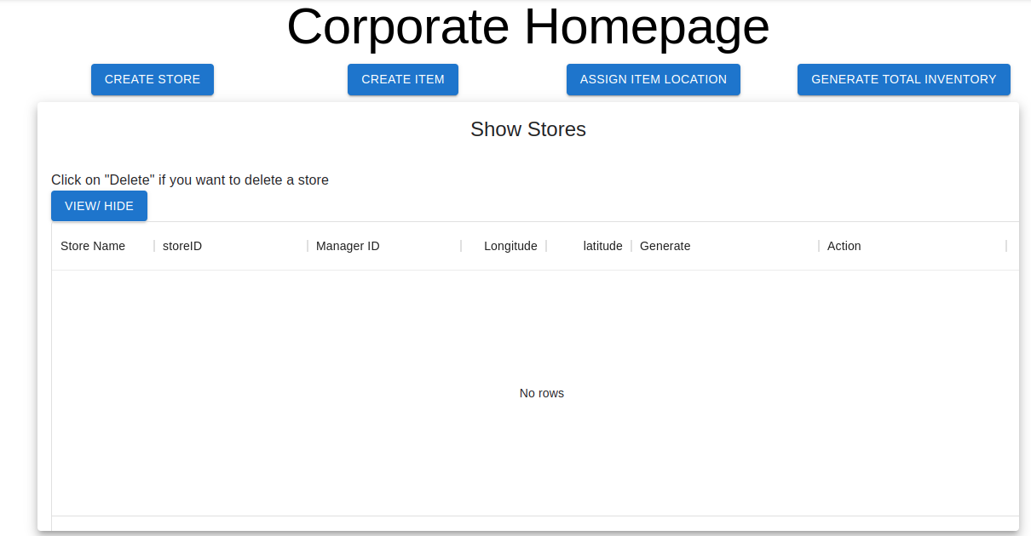

1. **Corporate – List Stores**

**Prerequisite:** logged in as a corporate user.

In the “Show Stores” window, you can click on “view/hide” in the “Show Stores” section. This will fetch a list of the stores that the corporate has created up to this point. Each row represents a store and contains information such as “store name”, “storeID”, “managerID”, “longitude” and “latitude”.

You can also find action related to that store such as generate inventory report or delete store.

Note: if no store exists, this table will display no rows.

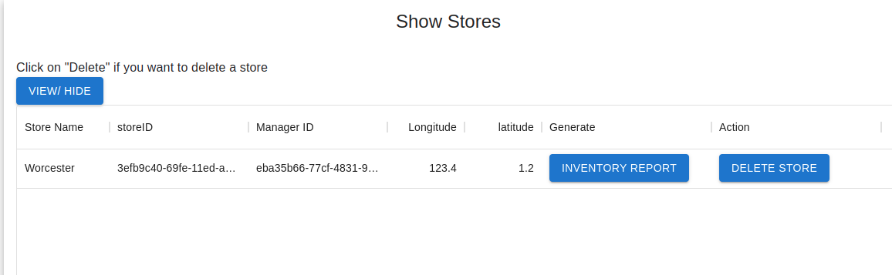

1. **Corporate – Remove Stores**

**Prerequisite:** logged in as a corporate user.

Simply click on “delete store” button in the rendered stores table in the previous step. The status (success/failure) of the action will appear just under the app bar.

Note: after deletion make sure to refresh the page.

1. **Corporate – Generate Store Inventory Report**

**Prerequisite:** logged in as a corporate user.

Simply click on “inventory report” button in the rendered stores table in the previous step. This action will lead you to a page displaying the Inventory Report for a store. The page looks like this.

**Note**: The first table shows quantity/valuation per item while the “summary” table shows total valuation and total number of items.

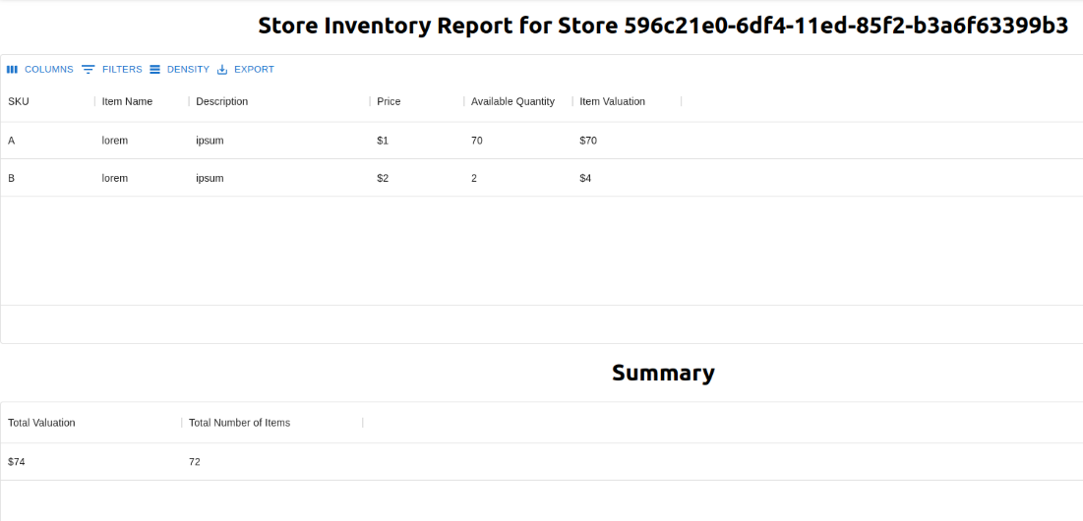

1. **Manager – Generate Overstock Report**

**Prerequisite:** logged in as a manager who has been assigned to a store.

In the Manager Homepage you will find all the use cases pertaining to manager actions. To generate overstock inventory report, simply click on the “generate overstock inventory report” in the horizontal button group under store ID.

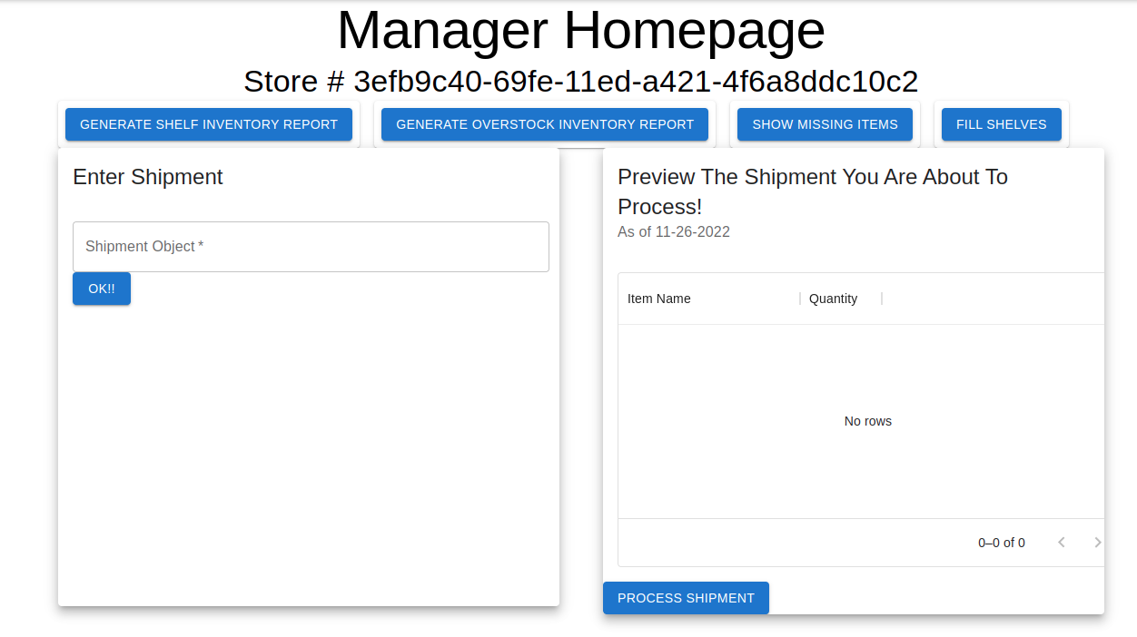

That action will lead you to a report displaying page that looks like this

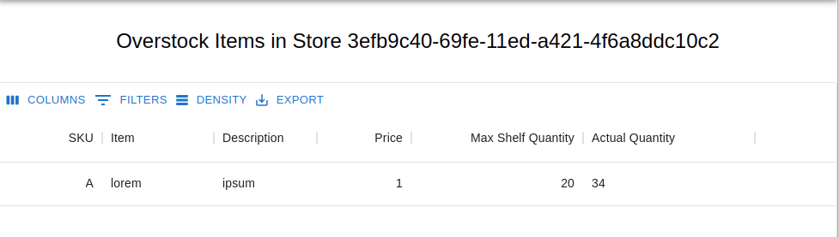

1. **Customer – List Stores**

Go back to customer homepage by clicking on “Logout” if you are currently logged in as either manager or corporate or clicking on the “burger” button and switch user role to “Customer”. Note: either method will log you out of the current session.

The customer homepage looks like this:

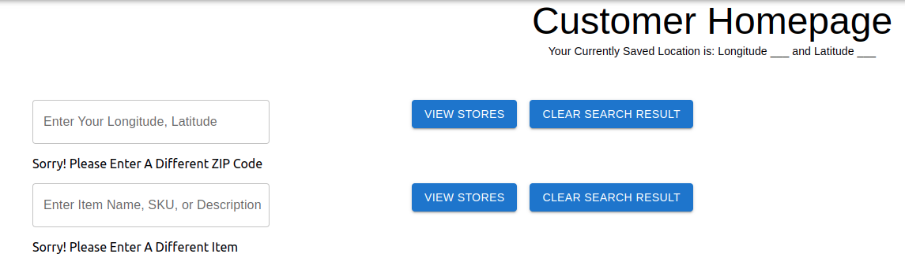

To list stores based on customer’s current longitude, latitude, please enter user input in the format:

Note: if you use a different format, our app might not be able to parse the data!

{longitude}, {latitude}

For example, 20.5, 30.5.

Note: input must be a string with two floating point numbers separated by a comma.

Clicking on “View Stores” will render a list like this. The stores in this list are sorted by distance from customer.

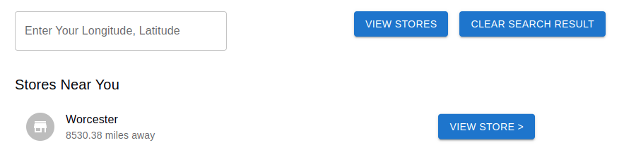

**Note:** when you first load the page, no customer GPS information is provided, so you will find this text display:

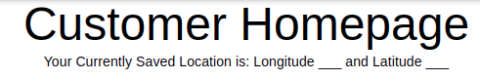

However, upon each “search by distance”, the text display will be updated to reflect the user input. This information will be used to the subsequent “list store by partially matched text” use case.

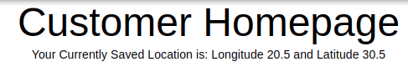

1. **Customer – Find items on Aisle/Shelf in Store**

In the rendered stores list in use case #5, you can click on button “view store >” to visit that store and see which items are on the shelf. The store layout looks like this.

**Note:** you can use the filter or sort features provided in the UI for any columns.



1. **Customer – Find items in Store by partially matched text**

**Prerequisite:** longitude/latitude information has been entered in use case #5

If you go back to “Customer Homepage”, you will find a text field with label “Enter Item Name, SKU, or Description”. Please make sure that some longitude/latitude information has been saved prior to searching by item as we need location information to sort search results by distance as well. Otherwise, you will get an error message like this.

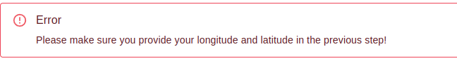

The search results look like this. You can click on “view store” to “invoke” use case #6.

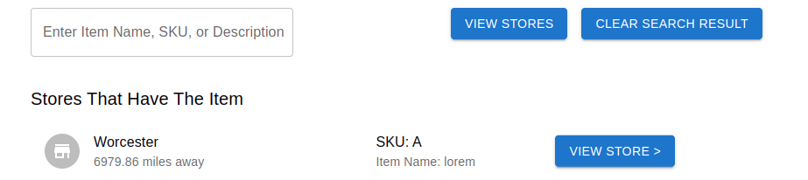

Note: if no stores carry the item you are looking for, you will notice a self-dismissing alert that says “Execution Completed! No stores carrying the item you are looking for”. No stores will appear in the store list since there are none and the text “Sorry! Please Enter A Different Item” will be displayed.

1. **Individual Contribution**

We will later provide a full history of git log in all CodeCommit branches. Here are the individual contributions for this iteration so far.

**Minh Hang Radetsky**

* Created front end for ‘Manager - fill shelves’ use case
* Created front end for ‘Customer - buy item’ use case
* Created back end for ‘Manager - fill shelves’ use case
* Created back end for ‘Customer - buy item’ use case

**Benjamin Gavrilov**

* Created Front End for Most Expensive item use case
* Created Front End for Missing Items use case
* Created Back End Lambda function for most expensive item
* Created back end lambda function for missing items use case
* Configured API gateway settings
* Created and started the final group collaboration report

**Julianna Bernardi**

* Created front end for Corporate Total Inventory report
* Created back end for Corporate total inventory report
* Deployed application
* Provided technical support to group members